DAD 220 Module Two Lab Template

Overview
To complete this lab, go to your Codio virtual lab environment and start a new terminal session. Once there, perform the steps below to complete this activity. Manually enter any commands you are asked to write.

At the end of each step in the activity, replace the bracketed text in this template with a screenshot, brief explanation, or both as indicated. Size each screenshot and its explanation to fit about one-quarter of the page with the description written below the screenshot. Review the Template Screenshot Example linked in the guidelines and rubric for this assignment to see an example of how screenshots for your assignment should look.

Create and Describe Database Tables

- Connect to the database you created and named in Module One (for example, Jetson). Type after the prompt mysql>. Validate your work with a screenshot.

  - USE (database you created);
    - Example: mysql> USE Jetson;

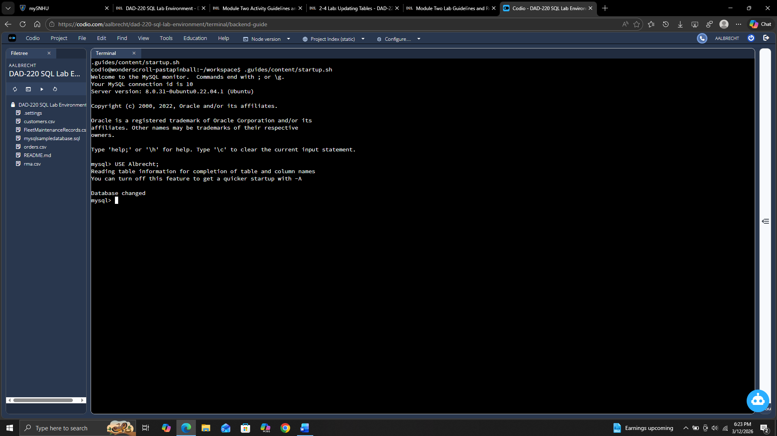

- Create the Employee table using the SQL statement shown here. Press Enter after each line. Validate your work with a screenshot.

CREATE TABLE Employee (
Employee_ID SMALLINT,
First_Name VARCHAR(40),
Last_Name VARCHAR(60),
Department_ID SMALLINT,
Classification VARCHAR(10),
Status VARCHAR(10),
Salary DECIMAL(7,2));

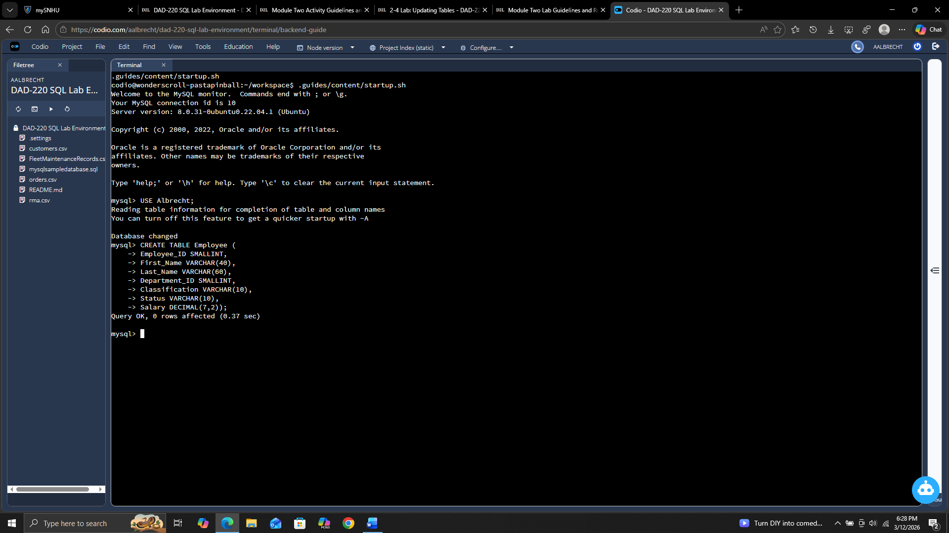

- Create the Branches table. Fill in the missing characters or punctuation in the incomplete statement shown below to complete this action. Validate your work with a screenshot.

CREATE Branches (
Department_ID SMALLINT,
Department_Name );

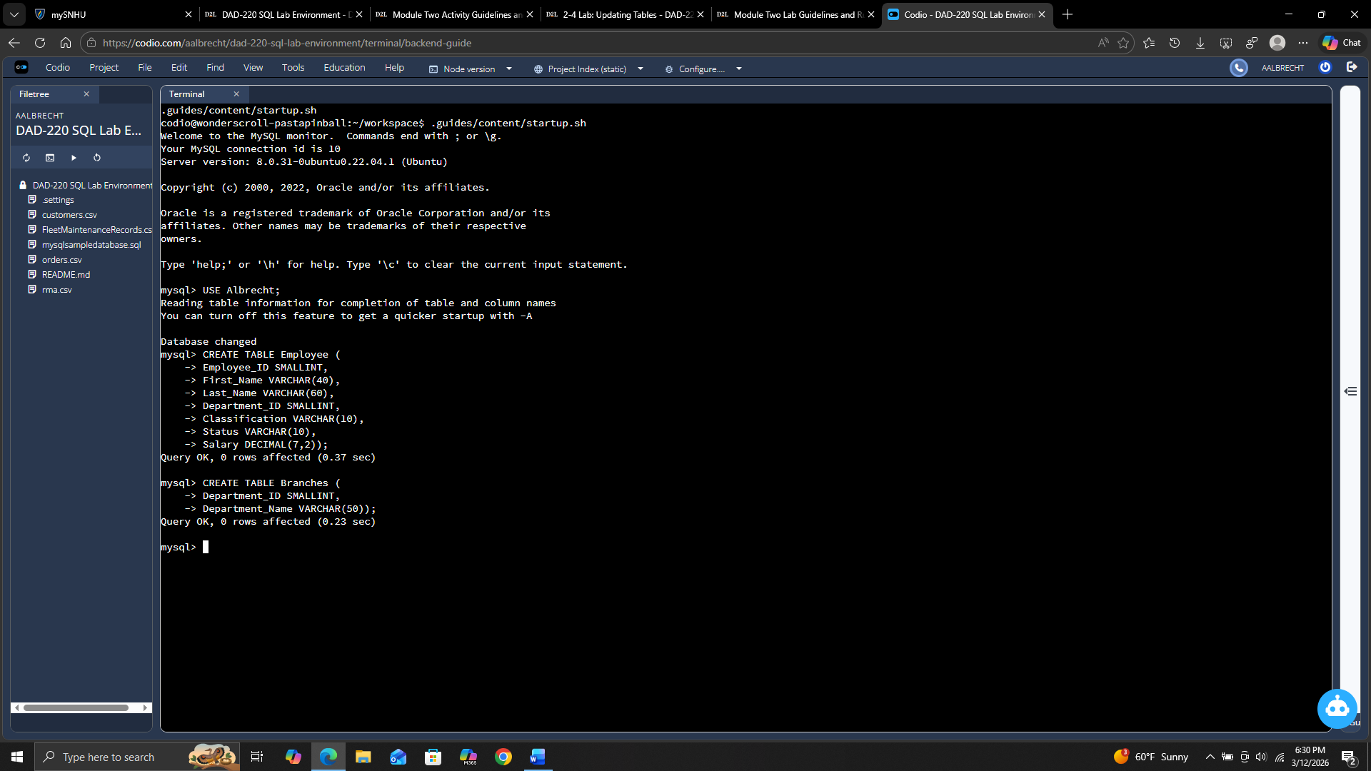

- After creating the tables, use the correct commands to describe the two tables. You’ll be given commands to describe one of the tables. You must complete the same action for the second table on your own. Validate your work with a screenshot.

  - DESCRIBE Employee;
  - Write the correct command to describe the Branches table.

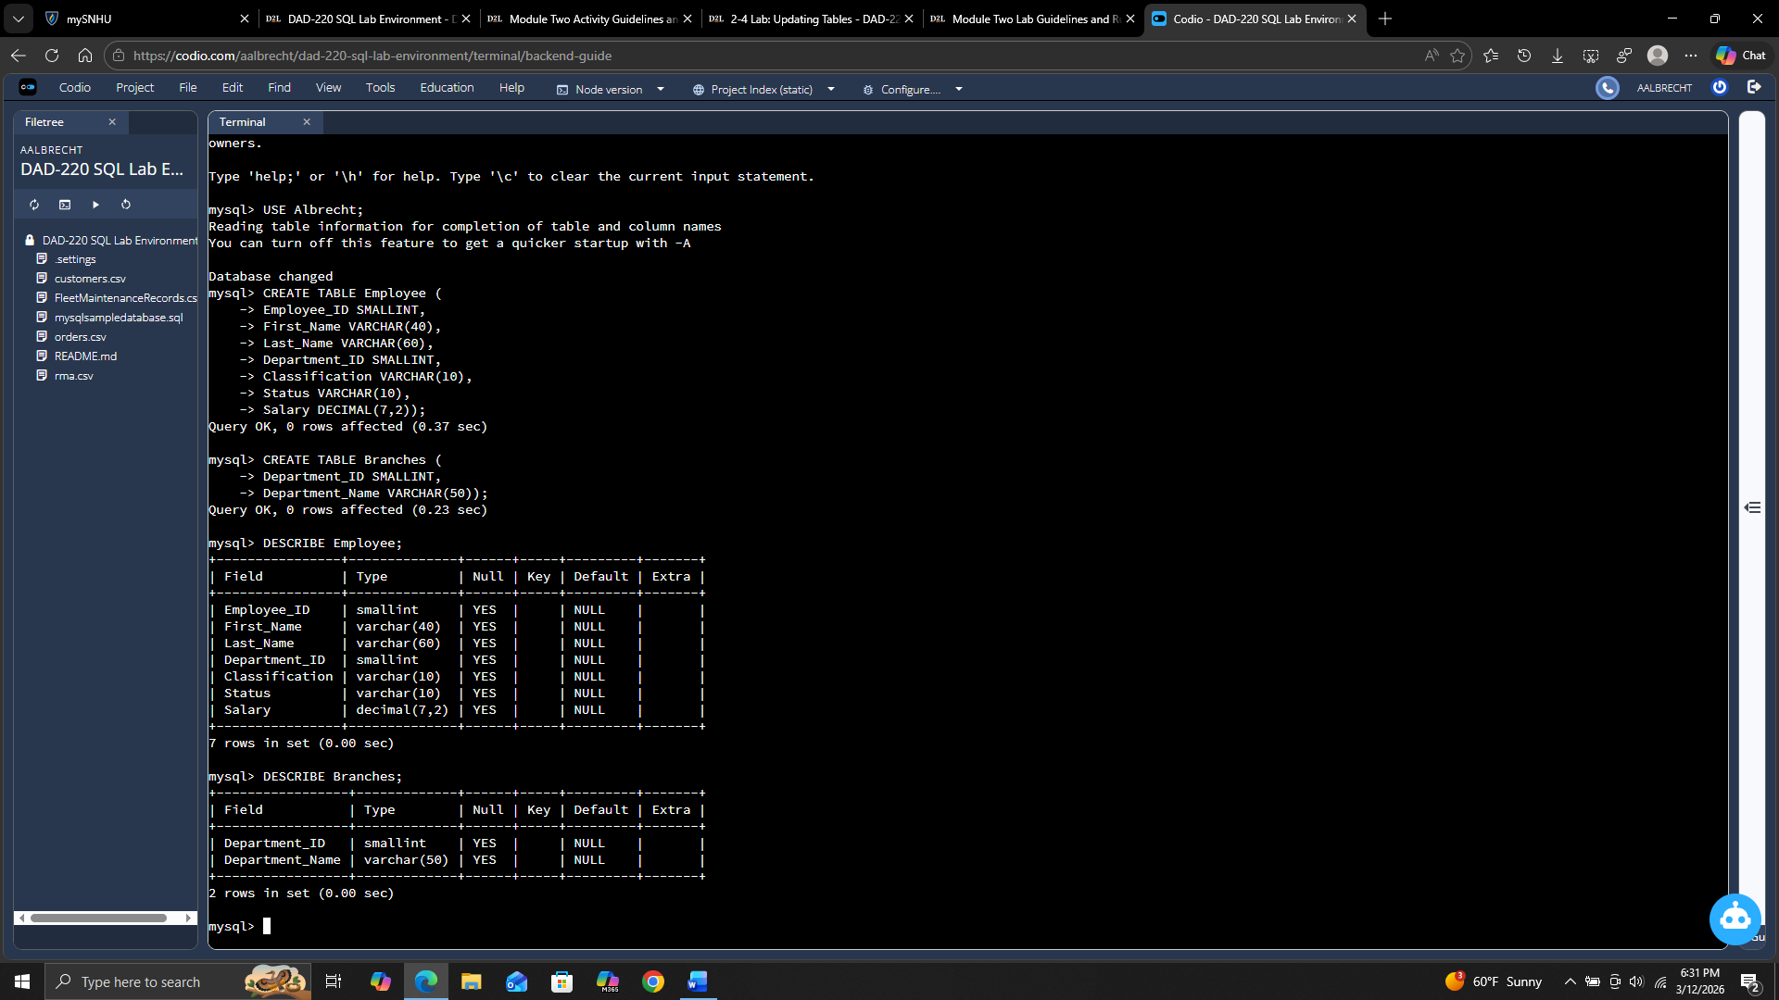

- Insert the following records into the Employee table (with support). Each line going from left to right is a record. Each line going from top to bottom is a column. Validate your work with a screenshot.

  - INSERT INTO Employee VALUES
(100, 'John', 'Smith', 1, 'Exempt', 'Full-Time', 90000),
(101,'Mary','Jones',2,'Non-Exempt','Part-Time',35000),
(102,'Mary','Williams',3,'Exempt','Full-Time',80000);
  - Type the command SELECT* FROM Employee.

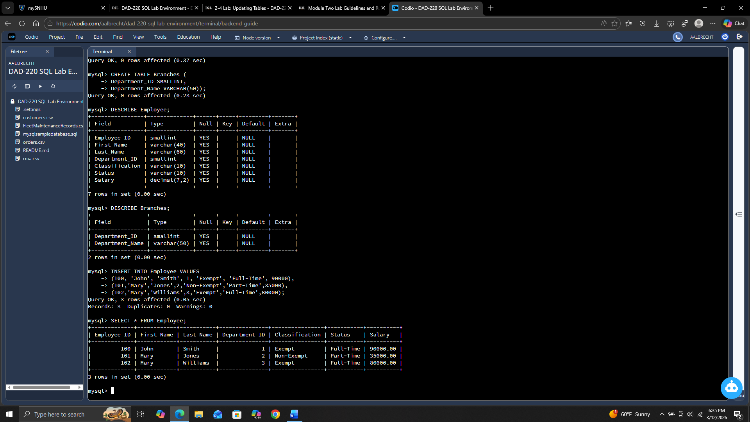

- Insert the following records into the Employee table for Gwen Johnson and Michael Jones by writing the correct SQL commands on your own (without support).

  - Gwen Johnson: Employee ID = 103, DEPARTMENT_ID = 4, Classification = NULL, Status = Full-Time, Salary = 40000
  - Michael Jones: Employee ID = 104, DEPARTMENT_ID = 4, Classification = Non-Exempt, Status = Full-Time, Salary = 90000
  - Insert your name into the table to verify and prove your work.
(Your First and Last Name, or a nickname): Employee ID = 105, DEPARTMENT_ID = 1, Classification = Non-Exempt, Status = Full-time, Salary = (Choose a value between 50000 and 99000)
  - Type the command SELECT * FROM Employee; and take a screenshot of it to validate this step.

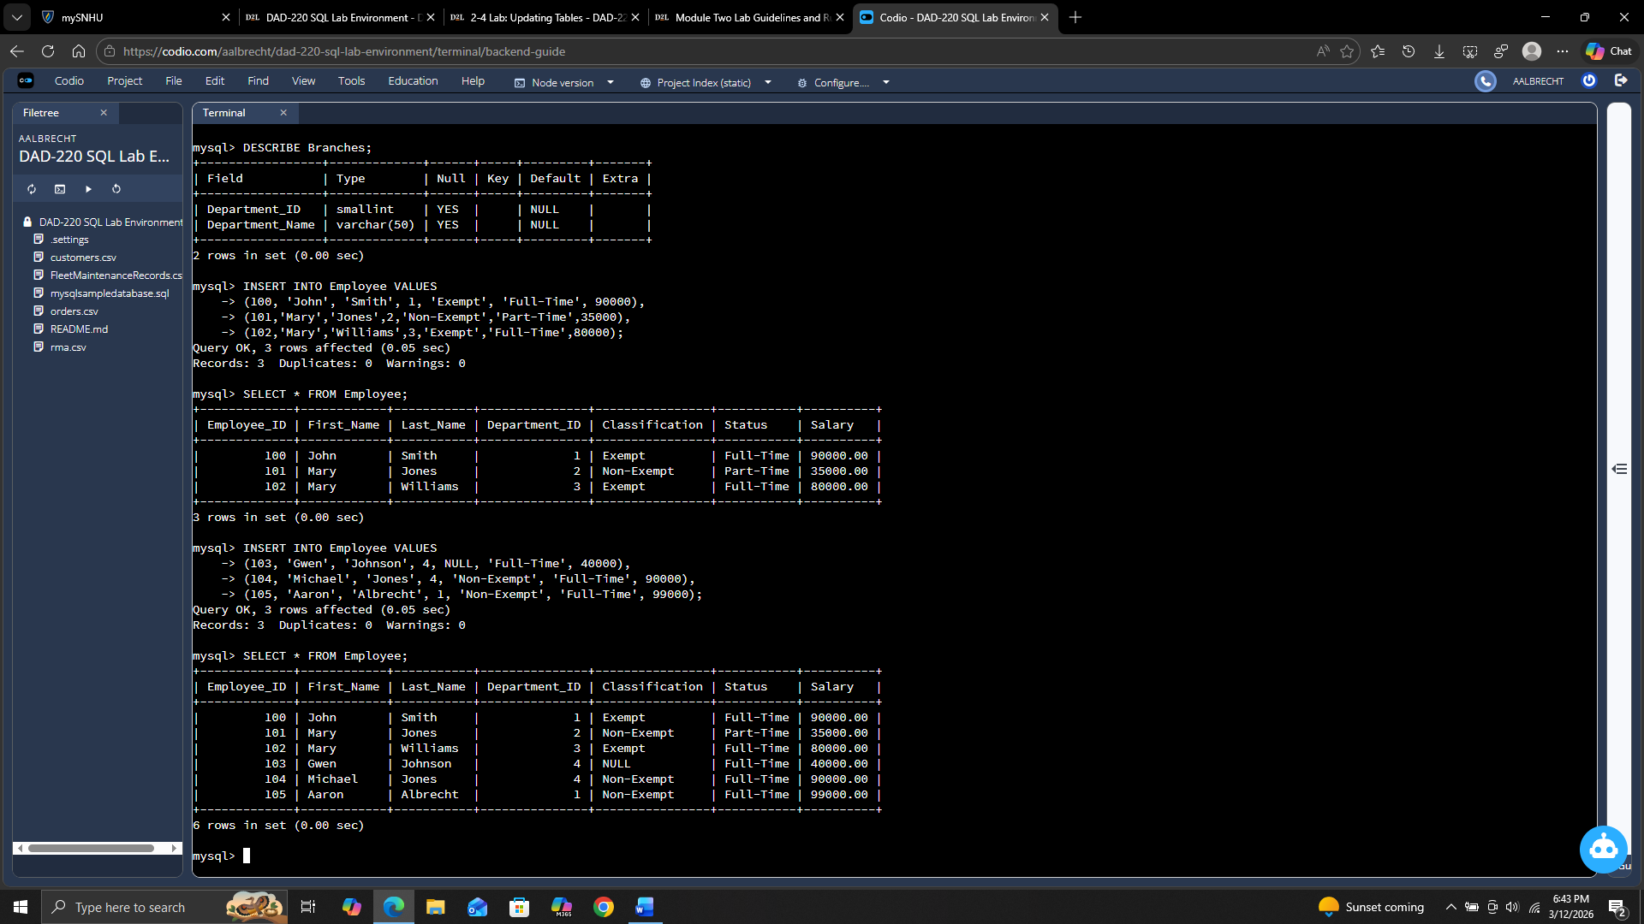

  - Insert records for a musician, athlete, or other famous character of your choice. Make sure to enter information for all of the fields listed in this table. The Department_ID must be a number between 1 and 4.
  - Write the correct command to prove that you’ve successfully completed this step and validate it with a screenshot.

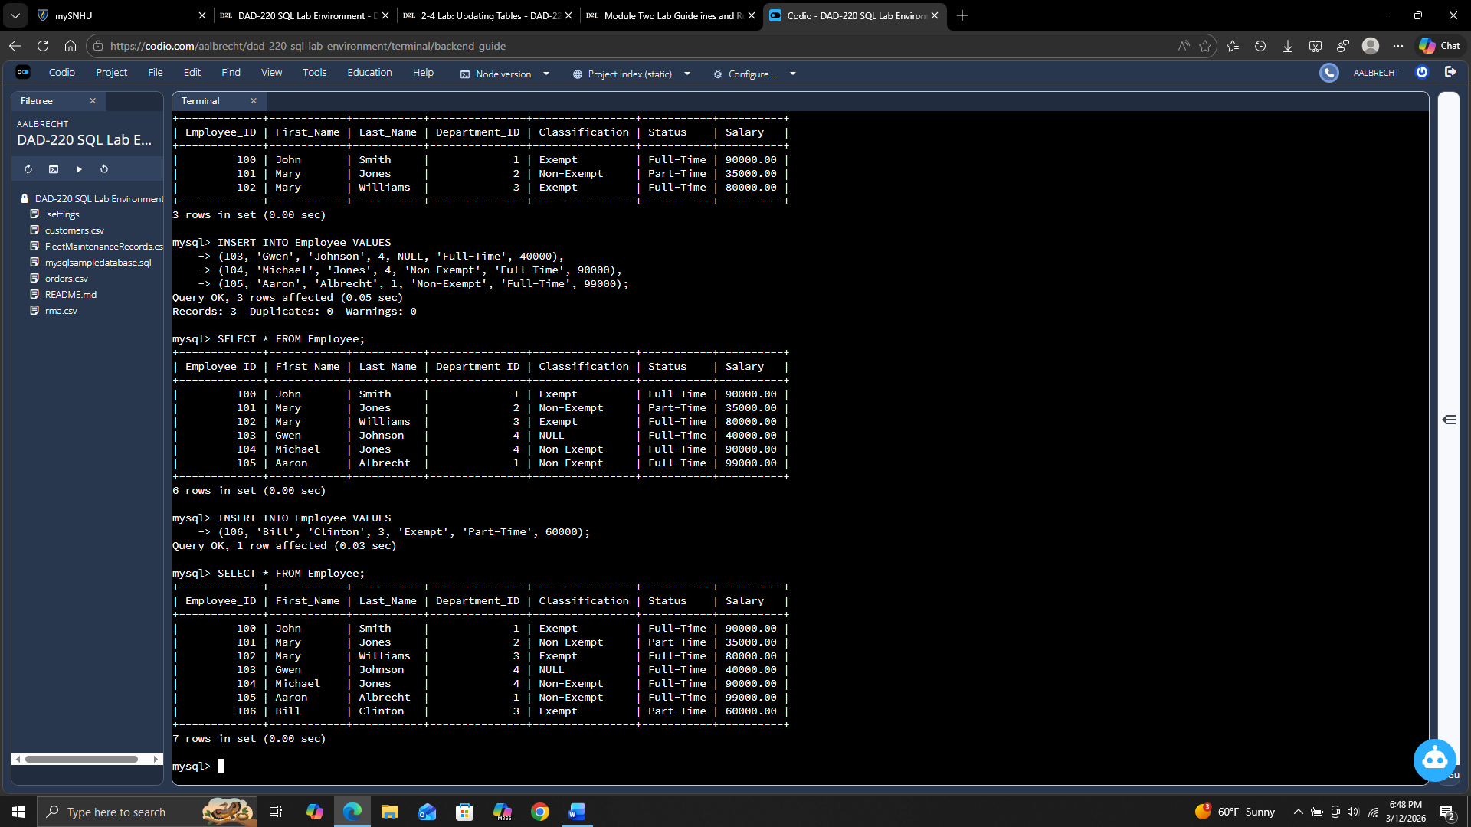
- Select the fields of first name, last name, employee ID, and department ID from the table. Validate your work with a screenshot.

  - SELECT First_Name, Last_Name, Employee_ID, Department_ID FROM Employee;

